**Training Report Day-7**

**13 June 2024**

**Object Oriented Programming in Python:**

Object oriented programming approach allows us to club together the data and behavior so that it becomes easier to code real world scenarios.

**Classes and Objects:**

* Objects are real world entities. Anything you can describe in this world is an object.
* Classes on the other hand are not real. They are just a concept.

Classes are defined by using ‘class’ keyword.

class Mobile:

    pass

To create an object, we need a class. The syntax for creating an object is "classname()", where classname is the name of the class.

Mobile()

Mobile()

Mobile()

**Attributes of an Object:**

Attributes are declared by using dot(.) operator with object.

Example:

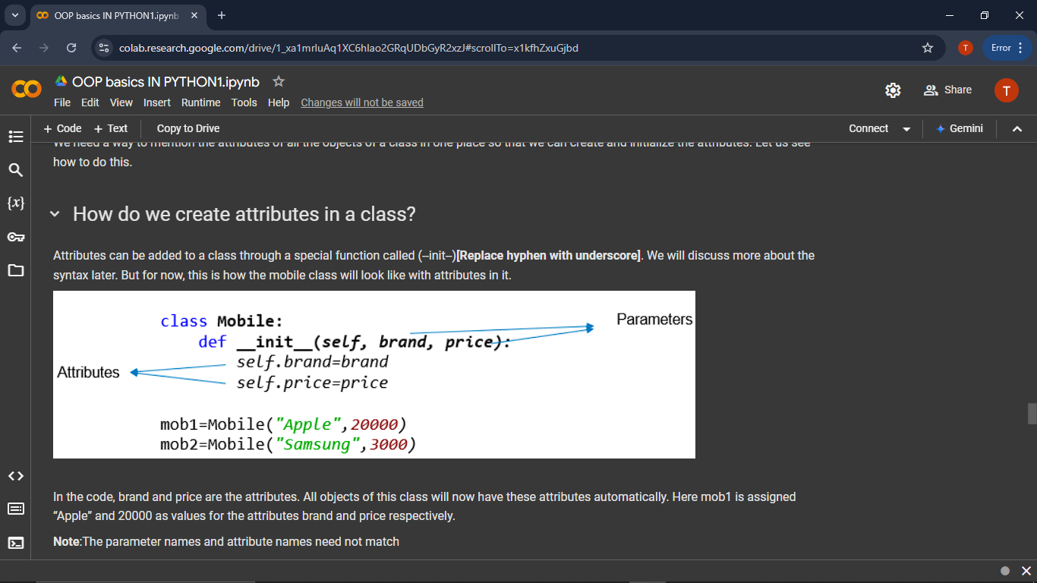

**Constructor & Self Introduction:**

When we create an object, the special __ init __() method inside the class of that object is invoked automatically. This special function is called as a constructor.

class Mobile:

    def __init__(self):

        print("Inside constructor")

mob1=Mobile()

self is not a keyword. self refers to the current object being executed.

class Mobile:

    def __init__(self):

        print("Id of self in constructor:", id(self))

mob1=Mobile()

id(mob1)

**Parameterized constructor :**

If a constructor takes parameters then it would be called as parameterized constructor.

class Mobile:

    def __init__(self, brand, price):

        print("Inside constructor")

        self.brand = brand

        self.price = price

mob1=Mobile("Apple", 20000)

print("Mobile 1 has brand", mob1.brand, "and price", mob1.price)

mob2=Mobile("Samsung",3000)

print("Mobile 2 has brand", mob2.brand, "and price", mob2.price)

class car:

  make = "hyundai"

  model = "verna"

  year = "2024"

obj1 = car()

print(obj1.make)

print(obj1.model)

print(obj1.year)

# question 2

class person:

  name = ""

  age= 0

  def greet(self,a,b):

    name = a

    age = b

    print("hello",name,"you are",age,"years old")

obj2 = person()

obj2.greet("rahul",23)

# question 3

class rectangle:

  length = 20

  breadth = 10

  def area(self):

    print(self.length*self.breadth)

obj3 = rectangle()

obj3.area()

# question 4

class student:

  name = "lovin"

  grade = [80,80,70,90,60]

  def avg(self):

    grade = self.grade

    print(sum(grade)/len(grade))

obj4 = student()

obj4.avg()